**CALL FORWARDING SYSTEM SIMULATOR**

SOFTWARE REQUIREMENT SPECIFICATIONS

**CFSS_01**

Application should maintain a database for the call forwarding details (user authentication, type, source and destination etc.,)

**CFSS_02**

* Application shall allow users to register or unregister for call forwarding service initially before enabling or disabling the service.
* Users register/unregister requests shall be authenticated using a database.

**CFSS_03**

**Admin shall allow add/delete/update of database entries**

* Add : Add new users to the database
* Delete : Delete an user from the existing database
* Update : Update the details of the existing user

**CFSS_04**

* Registered and Authenticated User can enable or disable the Call forwarding service anytime.
* No restriction on number of enable/disable of Call forwarding service

**CFSS_05**

On call connect from a User, Application shall check for activation of forwarding service using its database and if service is activated, then shall then forward accordingly depending on the call forwarding type

**CFSS_06**

**Shall support 3 types of call forwarding services i.e unconditional or No reply or as Busy**

* Unconditional : All calls will be forwarded to that particular person.
* No reply : If the call rings for particular timestamp and the person didn’t pick the call, then the call will be forwarded.
* Busy : The person can forward the call if he/she is busy.

**CFSS_07**

Shall log all user requests and forwarded calls with date timestamp.

**CFSS_08**

Shall allow authenticated and registered users to activate or deactivate the service as per their requirement

**CFSS_09**

Once unregistered, no forwarding service shall be provided

**CFSS_10**

Shall receive normal calls addressed to the user if service is deactivated else all incoming call to be handled as per call forwarding service type

**CFSS_11**

Should include debug log messages with atleast 4 levels (FATA, INFO, WARNING, DEBUG)  
<https://stackoverflow.com/questions/2031163/when-to-use-the-different-log-levels>

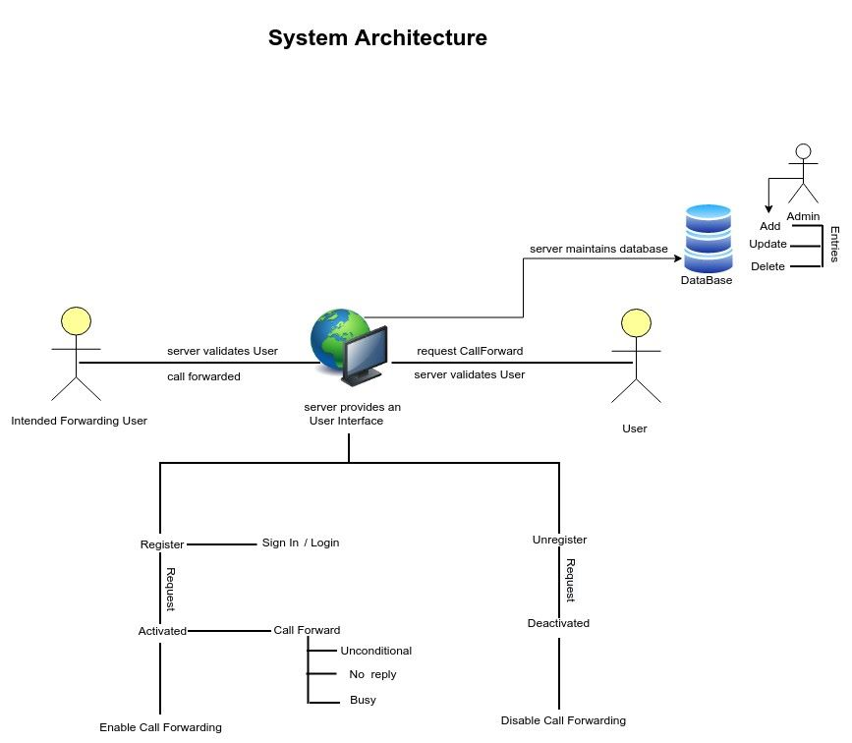

Desirable Outcome

The application should run (after compilation) on LINUX as well as windows